

LAB 4-HOME

NAUMAN TASAWAR



[Date]

[Company name]

[Company address]

**Topology:**

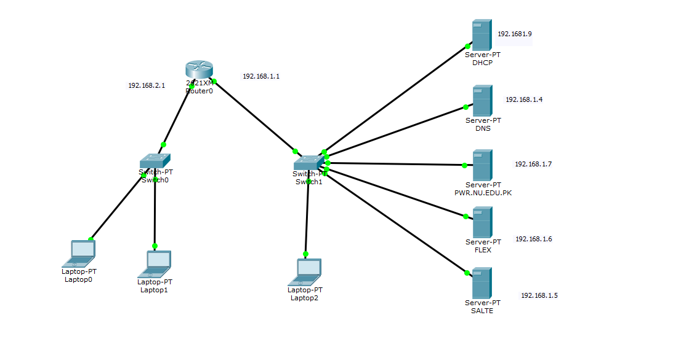

**Router Config:**

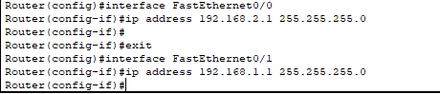

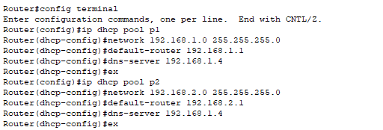

**DHCP CONFIG:**

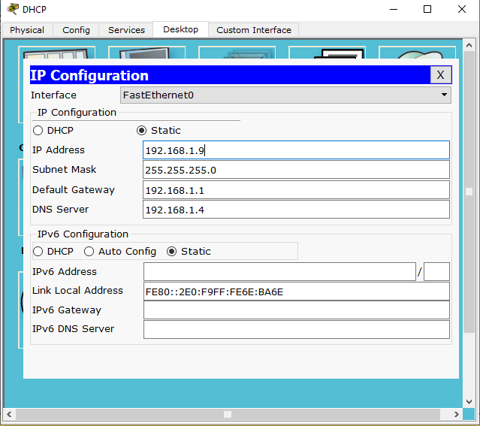

**DNS CONFIG:**

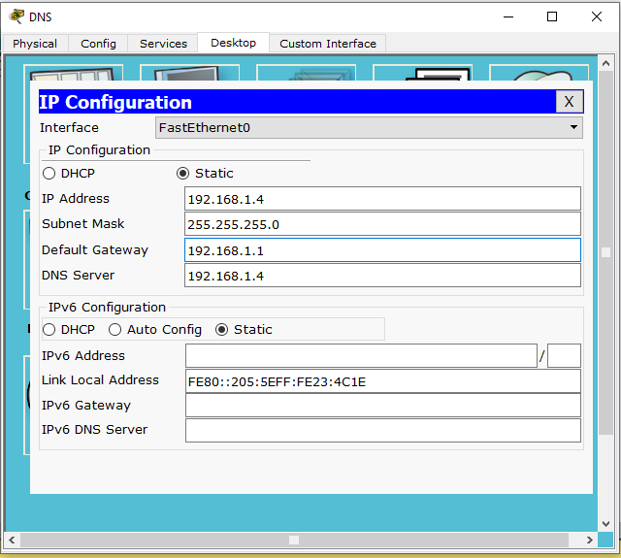

**PWR.NU.EDU.PK WEB SERVER CONFIG:**

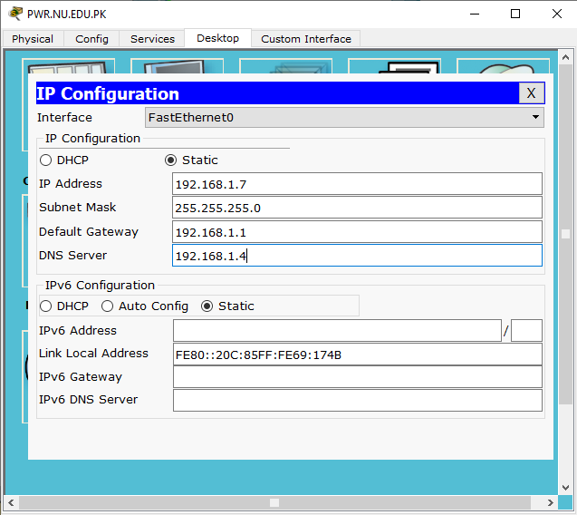

**FLEX WEB SERVER CONFIG:**

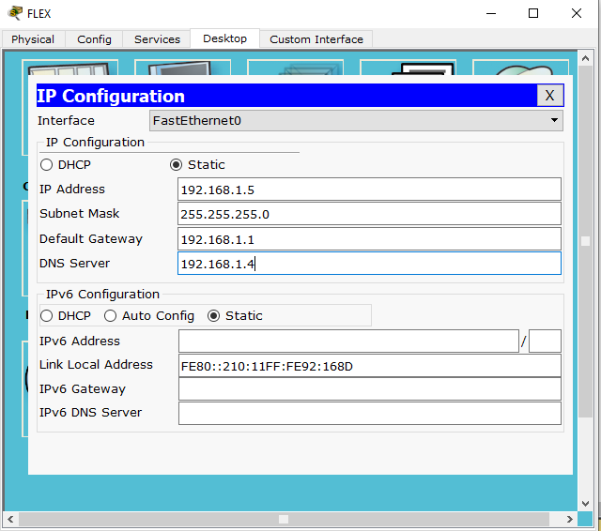

**SLATE WEB SERVER CONFIG:**

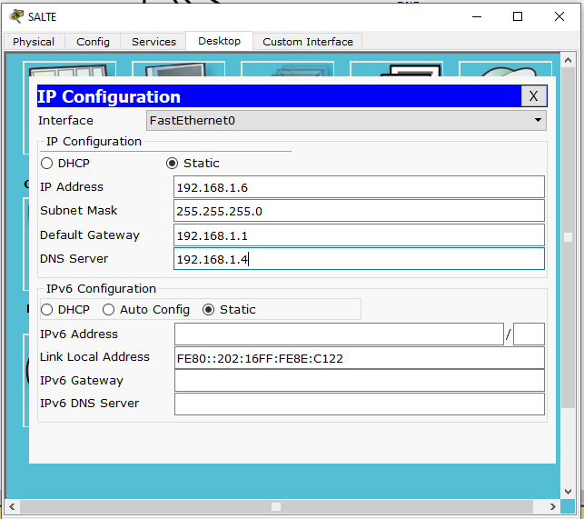

**DHCP POOL P1:**

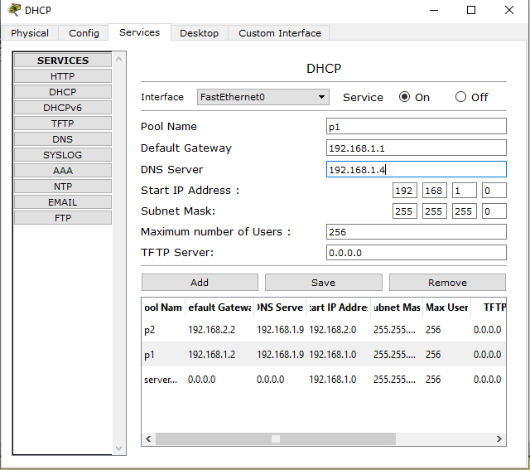

**DHCP POOL 2:**

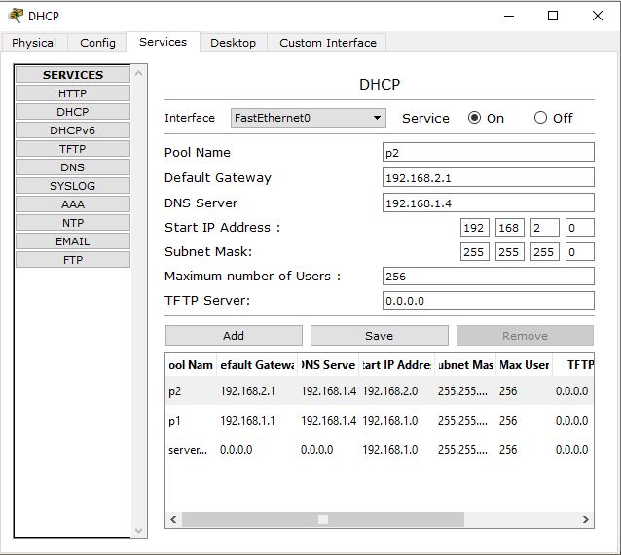

**DNS WEB IP ALLOCATION :**

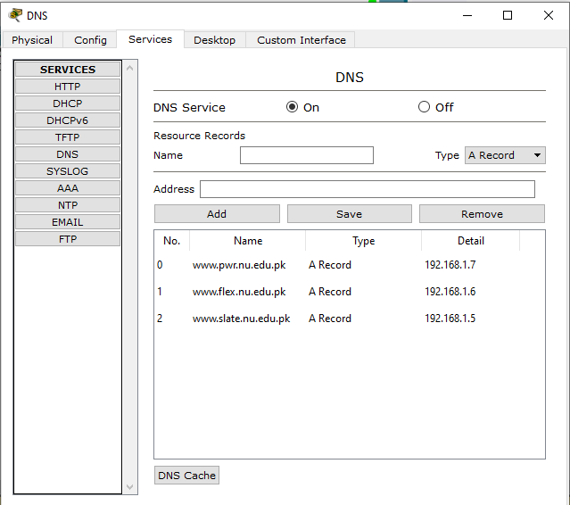

**FLEX SERVER SITE INDEX:**

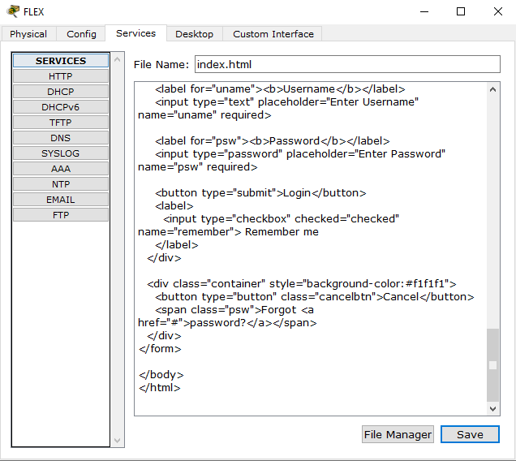

**SALTE SITE INDEX:**

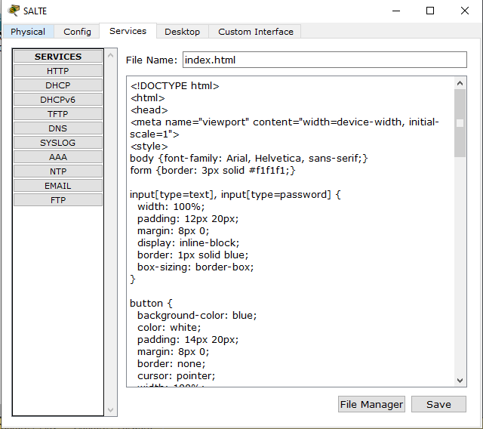

**PC TO SLATE:**

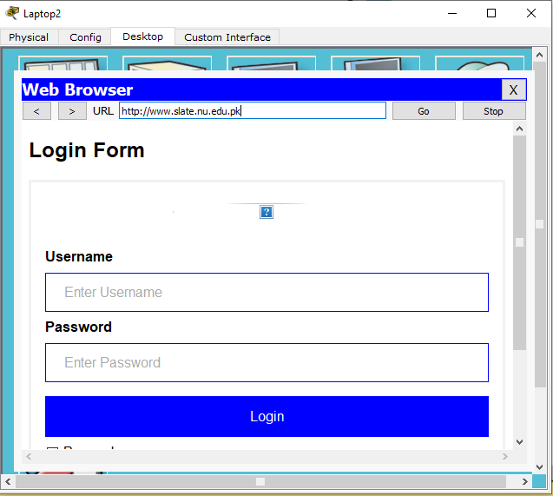

**Pc to flex:**

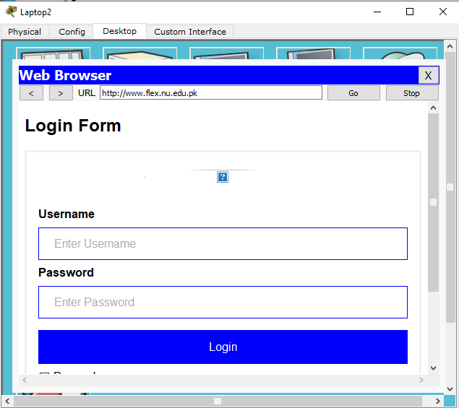

**Observation 1**:

When I hit the ip from pc the the request will go to web server:

**Observation 2:**

When I type the url from the pc the request went to the dns server , and on the second time when I type the same url the request went direct to webserver .